Assignment 3

Question1 :

Let A = {2, 3, 4} and B = {6, 8, 10} and define a relation R from A to B as follows: For all (x, y) ∈ A × B, (x, y) ∈ R means that y / x is an integer.

a. Is 4 R 6? Is 4 R 8? Is (3, 8) ∈ R? Is (2, 10) ∈ R?

(4,6) ∉ R because 6/4 is not an integer.

(4,8) ∈ R because 8/4=2 which is an integer.

(3,8) ∉ R because 8/3 is not an integer

(2,10) ∈ R because 10/2=5 is an integer.

1. Write R as a set of ordered pairs.

R = {(2,6),(2,8),(2,10),(3,6),(4,8)}

1. Write the domain and range of R.

Domain: (2,3,4)

Range: (6,8,10)

1. Draw an arrow diagram for R.

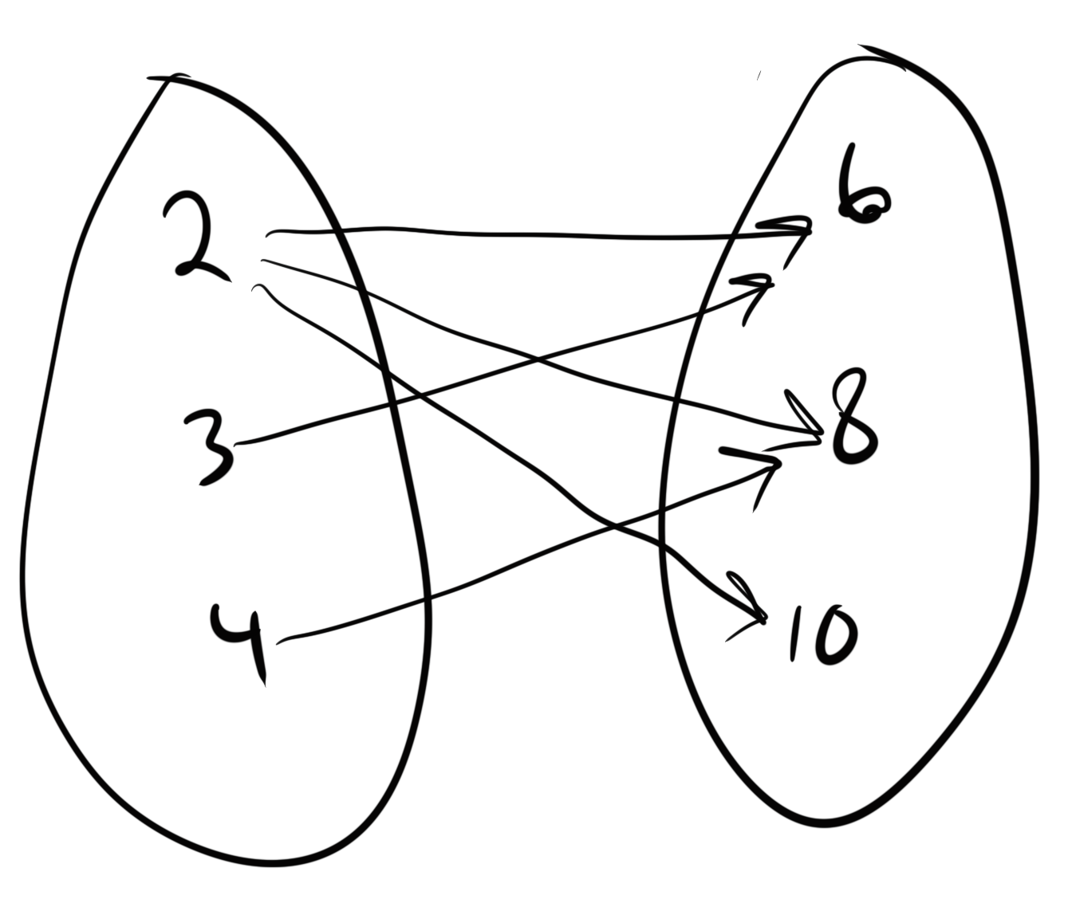

Question2 :

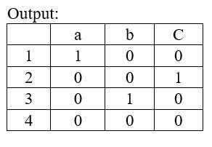Let C = {1, 2, 3, 4} and D = {a, b, c, d}. Define a relation R from C to D representd by the following arrow diagram:

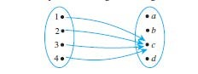

1. Write the domain and range of R.

Domain: {1,2,3,4}

Range: {c}

1. Is R reflexive, symmetric or transitive?

No, No, and No. Reflexive and symmetric would require C and D to share common members. Transitive would require that there be three sets and 2 R’s. d

Question 3:

Write a C++ program to:

1.Generate a matrix for a given set and relation:

Input:

A={1, 2, 3, 4 }

B={ a, b, c}

R={ (1,a) , ( 2,c) , (3, b) }

2. Generate two matrix tor two relations (you can assume the relations) that multiply two matrices, then find the composition matrix using matrix multiplication.

Note: You need to submit the source code and the output.